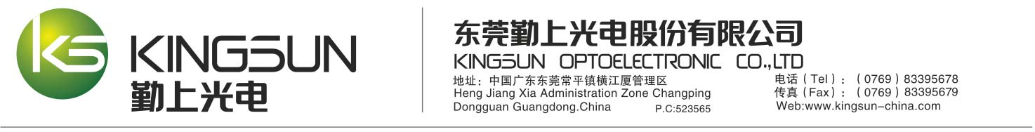**.**

**LIMITED LETTER OF WARRANTY**

Dongguan Kingsun Optoelectronic Co., Ltd，HengJiangXia Administration Zone, ChangPing, Dongguan, Guangdong China, referred to herein as “Kingsun", warrants its products to be free from defects of material and workmanship for a period of five (5) years for which Artemis LED Canopy Light item number are BY2G28044S140V27、BY2G28054S140V27、BY2G28064S140V27、BY2G28074S140V27、BY2G28084S140V27、BY2G28094S140V27、BY2G28104S140V27 (including driver,LED and PCB), Kingsun will under warranty obligation, repair or replace defective part/product at their discretion.

Definition of Defect: LED defects including burn out, loose, broken, un-workable PC board etc. technical and material, workmanship of the light can be considered defects under this warranty obligation. Driver defects includes functional problems, power factor etc. which affect the solid function of the product will be considered as defects under this warranty obligation.

This warranty does not apply to any product or part that has been subject to misuse, negligence, accident, use outside of product design intent, or attempted repair/modification by anyone other than Kingsun. Kingsun’s sole liability for defects or breach of warranty shall be replacement of the parts involved, and, in no event will Kingsun be liable for special or consequential damages or losses including property damage or other loss as related directly or indirectly to the use of Kingsun luminaire. In no event is Kingsun liable for consequential damages or personal injury caused by installation and transportation or negligence during installation and transportation or adjustment. Kingsun claims no liability for the cost of installation or any other cost incurred during the use of products manufactured by Kingsun. No representative is authorized to assume additional liability for Kingsun.

All returns must be factory authorized and Kingsun must issue a Return Material authorization (RMA), prior to shipping. Returns will be shipped at buyer’s expense.

If Kingsun finds the product working properly, Buyer may be billed for testing, re­packaging, and shipping. If Warranty has expired, Kingsun will provide a quote to repair prior to making any such repairs. If product was under Warranty and Kingsun replaces or repairs the defective product, Kingsun will pay for return shipping to the customer. In no case will Kingsun be liable for any cost incurred in removing or installing the product, even if the product had failed under a covered Warranty.

Kingsun reserves the right to make product specification changes to any product at any time, as deemed necessary without prior notice to the customers.

For pricing information on out of warranty repair, contact Kingsun Customer Service at 86-769-83395678 ext. 8067. No other warranties are implied and there are no warranties extended beyond those stated herein.

**Dongguan Kingsun Optoelectronic Co., Ltd.**

HengJiangXia Administration Zone,

ChangPing, Dongguan,

Guangdong China